**PROCESS CONTROL BLOCK**

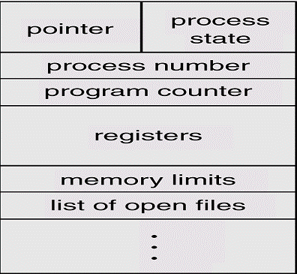

* Each process in O.S. is represented by a PCB (process control block) also called a task control box.
* It is identified by an integer process Id (PID).
* A PCB keeps all the information needed to keep track of processes as listed below.

1. PROCESS STATE

It includes the current state of process i.e. new, ready, running, waiting or halted and so on.

1. PROGRAM COUNTER

It indicates the address of next instruction to be executed for this process.

1. CPU REGISTERS

They include accumulators, stack pointers (SP), index pointers and general purpose registers, plus any conditions – code information.

1. CPU SCHEDULING INFORMATION

It includes process priority, pointer to scheduling queues, and any other scheduling parameters.

1. MEMORY MANAGEMENT INFORMATION

It includes the information such as value of base and limit registers, page tables are segment tables depending on the memory used by O.S.

1. ACCOUNTING INFORMATION

This includes the amount of CPU and real time used, time limits, job or process numbers and so on.

1. I/O STATUS INFORMATION

It indicates a list of I/O devices allocated to the process.